GUÍA EVALUADA DE RESUMEN UNIDAD 0
Guía n° 1 First Conditional
INGLES

Nombre: |  |  |  | Curso: | IVM A-B | Fecha
Puntaje Evaluación |  |  | Puntaje de corte (60%):
Puntaje obtenido: |  |  | Calificación:

INSTRUCCIONES:
-Leer la explicación gramatical de uso de 1STconditional
-ver ppt 1st conditional.
- Practica online
-Desarrollar Guía.

- UNE LAS DOS PARTES DE FIRST Conditional , EDITALO Y ENVIALO A PAULA.ARACENA @ELAR.CL
HASTA MARTES 24 DE MARZO.

Objetivos: REIFORCE FIRST CONDITIONAL
Contenidos:
FIRST CONDITIONAL

ITEM I.- PRESENTACIÓN DEL CONTENIDO,

First conditional

Meaning and use
We use the first conditional to talk about possible future situations (or ‘conditions’) and their results.We use if for things we think are likely to happen, and when for things we think are certain to happen.
If I visit London, I’ll stay with friends.
It is’t certain that I will go to London.
When I visit London, I’ll stay with friends.
It’s certain that I will go to London.

Form
A conditional sentence usually has two parts:
the if/when part and the result (main) part. For the first conditional we use the present simple in the if/when part, and will + infinitive (without ‘to’) in the main part.
Conditional clause (if/when part) + Main clause (main part)
If/When + present simple - will + infinitive without to
The two parts can be in any order. When we write, when the if part comes first, we put a comma between the if/when part and the main part. We don’t use a comma when the main part comes first.
If I visit London, I’ll stay with my friends.
I’ll stay with my friends if I visit London.
When she gets home tonight, she’ll give you a call.
She’ll give you a call when she gets home tonight.

Positive
If you’re late, we’ll wait for you.
When I get home, I’ll call you.
They’ll go to the beach if it’s sunny.

Negative
When I get home, I won’t watch TV.
If we don’t hurry, we’ll miss the train.
They won’t go to the beach if it isn’t sunny.
Question
When you finish school, what will you do?
How will he feel if he doesn’t get the job?
If you pass your exams, will you go to university?
Short answer Yes, I will. / No, I won’t.
Take Note: modals
We can use modals such as may, might, can or should in first conditional sentences. May and might show we are less certain than when we use will.

We might be late if the shops are busy.
If I feel unwell tomorrow, I may stay at home.
You shouldn’t use the kettle if it isn’t working properly.
If you can’t finish your homework tonight, you can’t go out tomorrow.
When you can smell the cake, you’ll know that it’s cooked.

Take note: going to and present continuous with future meaning
We can use going to or the present continuous with future meaning in the if/when part or the main part.
If we don’t leave right now, we’re going to be late.
If you’re playing tennis later, you’ll need to take your racket.

Take note: as long as and unless
We can use as long as and unless with the same meaning as if and if not:
As long as we leave now, we won’t be late. (= If we leave now, we won’t be late.)
Unless we leave now, we’ll be late. (= If we don’t leave now, we’ll be late.)

Spoken English
The will in the first conditional can be shortened to ’ll in both speaking and informal writing. In the negative form, will not can be shortened to won’t.
If I lose my umbrella, I’ll buy another one.
We won’t be pleased if we miss our flight.
It is sometimes difficult to hear the shortened form ’ll before the infinitive. But it’s important to remember it!

ITEM II.- Diapo 1st Conditional

ITEM III.- Make the first conditional

https://www.perfect-english-grammar.com/first-conditional-exercise-1.html

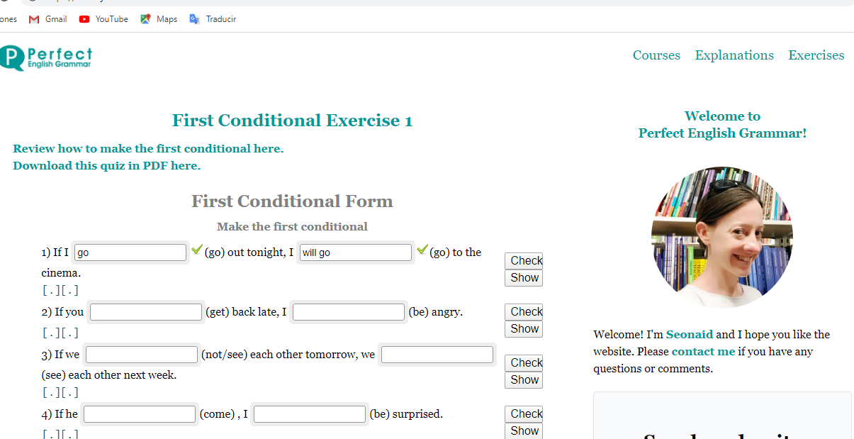

Unit o
First Conditional-

Name: |  | Grade | IV MEDIO A-B | Date

UNE LAS DOS PARTES DE FIRST Conditional , EDITALO Y ENVIALO A PAULA.ARACENA @ELAR.CL

Beliefs based on fear of the unknown and faith in magic or luck: beliefs that certain events or things will bring good or bad luck.
Match these superstitions to the right endings. Cut and paste
If you walk under a ladder, | - you will have bad luck for seven years.
- If you open an umbrella inside the house, | - she will be the next to marry.
- If a girl catches the bride’s bouquet after the wedding, | - you will get some money.
- If you open an umbrella in fine weather, | - you will have bad luck.
- If you break a mirror, | - you will have good luck.
- If you catch a falling leaf in autumn, | - it will bring misfortune for the household.
- If you see a four-leaf clover, | - you will lose some money.
- If the palm of your right hand is itchy | - you will have good luck.
- If the palm of your left hand is itchy, | - it will bring rain.

Unit o
First Conditional

Name: |  | Grade | IV MEDIO A-B | Date

Beliefs based on fear of the unknown and faith in magic or luck: beliefs that certain events or things will bring good or bad luck.
Match these superstitions to the right endings. Cut and paste
- If you walk under a ladder, | - you will have bad luck for seven years.
- If you open an umbrella inside the house, | - she will be the next to marry.
- If a girl catches the bride’s bouquet after the wedding, | - you will get some money.
- If you open an umbrella in fine weather, | - you will have bad luck.
- If you break a mirror, | - you will have good luck.
- If you catch a falling leaf in autumn, | - it will bring misfortune for the household.
- If you see a four-leaf clover, | - you will lose some money.
- If the palm of your right hand is itchy | - you will have good luck.
- If the palm of your left hand is itchy, | - it will bring rain.

